**STUDENT-ALUMNI INTERACTION**

The project will help in connecting the alumni and the students of the current batch. Alumni can create a page for themselves on the portal specifying the skill/sector they have mastered. Students can connect to them by asking relevant questions.

**Tables of database :**

1. Alumni
2. Student
3. Questions

ATTRIBUTES OF ALUMNI TABLE :

1. Name
2. College Roll No. (Primary Key)
3. Batch
4. Course
5. Skills (Tags + other)
6. Achievements
7. About (250 words max)

ATTRIBUTES OF STUDENT TABLE :

1. Name
2. College Roll No. (Primary Key)
3. Year
4. Course
5. Skills interested in

ATTRIBUTES OF QUESTION TABLE :

1. Question ID
2. Question
3. Question Category
4. Asked by
5. Answer (Array of arrays : [[answer1,answered by],[answer 2,answered by],....])

LINK FOR UI

<https://balsamiq.cloud/sdqdei4/pms5tze>

ER DIAGRAM

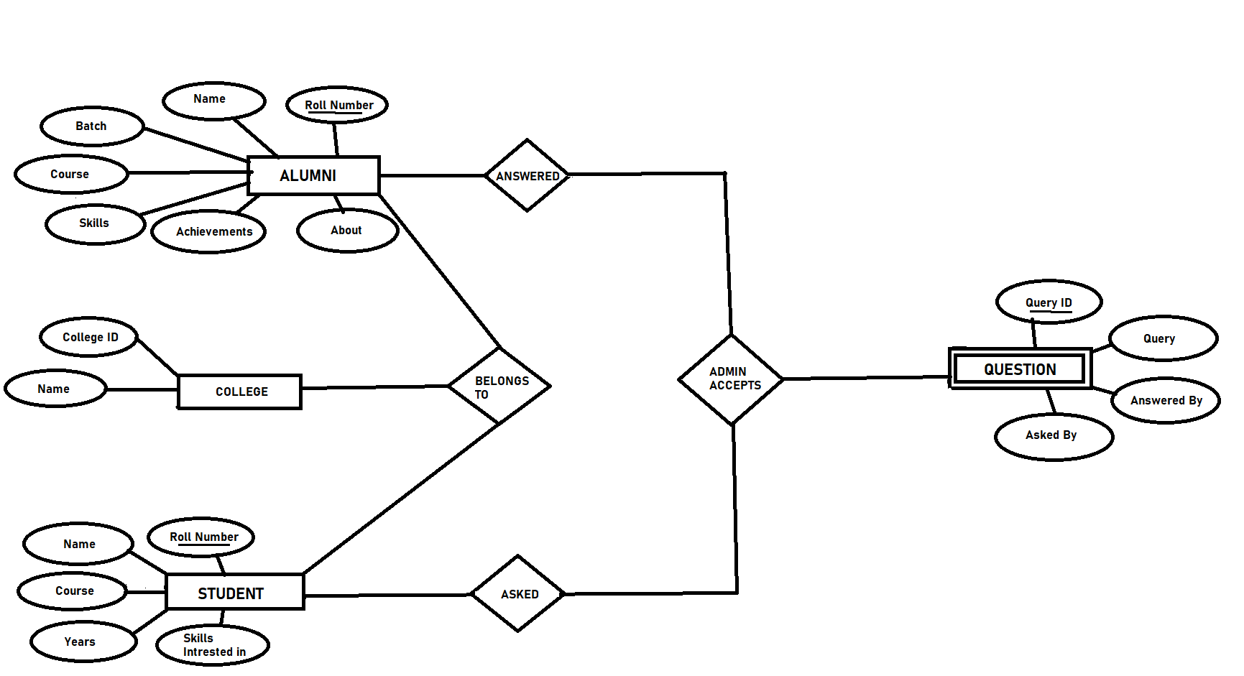

MINI-WORLD DESCRIPTION :

The project will allow alumni to interact with the students and answer their queries.

An alumni can be identified by his college id, roll number. In addition he will have following attributes :

1. Name
2. Batch
3. Course
4. Skills (Tags + other)
5. Achievements
6. About (250 words max)

SKILLS will be in the form of pre-defined tags that will help in filtering queries that are visible to them. The information provided by them will be reflected on their personal webpage.

A student can login in to the system with his roll,college ID. At the time of login he will have to add skills in which he is interested which will help in filtering questions based on their interest.

When a student asks a question the question is sent to the admin and once the admin approves the query it will get stored in the database and is reflected to the alumni if the question belongs to the same category.

When a question is answered by anyone the response is received by the admin and once the admin accepts the response the answer is stored in the database corresponding to the query ID. Thus the answer is visible for fellow students to read.

DATA REQUIREMENTS :

I. Alumni and Students identified by their college ID and college Roll.

II. Admin to accept query and response

ENTITY SETS :

1. Alumni
2. Student
3. College
4. Question (Weak Entity Set)

RELATIONSHIP :

1. ASKED : student asks query
2. ANSWERED : alumni answers that query
3. BELONGS TO : student and alumni belongs to some college
4. ACCEPTS : admin accepts query and answers